PIZZA SALES QUERIES BY ABUBAKAR AZEEZAT

1. TOTAL REVENUE:

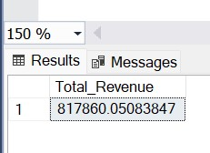SELECT SUM(total_price) AS Total_Revenue from Pizza;

1. AVERAGE ORDER VALUE:

SELECT SUM(total_price)/COUNT(DISTINCT order_id) AS Avg_Order_Value FROM pizza;

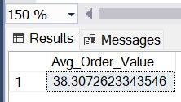

1. TOTAL PIZZA SOLD:

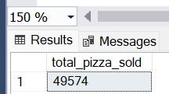 SELECT SUM(quantity) AS total_pizza_sold FROM pizza;

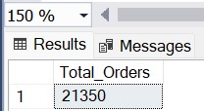 4.TOTAL ORDERS: SELECT COUNT(DISTINCT order_id) AS Total_Orders FROM Pizza;

5.AVERAGE PIZZA PER ORDER:

SELECT CAST(CAST(SUM(quantity) AS DECIMAL(10,2)) / CAST(COUNT(DISTINCT order_id)

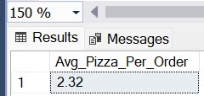 AS DECIMAL(10,2)) AS DECIMAL(10,2)) AS Avg_Pizza_Per_Order FROM Pizza;

**SECTION B CHART QUERIES ANALYSIS**

6. DAILY TRENDS:

SELECT DATEPART(DW, order_date) as order_day, COUNT(distinct order_id) as

total_orders from pizza group by DATEPART(DW, order_date);

7.HOURLY TRENDS:

SELECT DATEPART(HOUR,order_time) AS Order_Hours, COUNT(DISTINCT order_id) AS

Total_Orders FROM Pizza GROUP BY DATEPART(HOUR, order_time)ORDER BY DATEPART(HOUR,order_time);

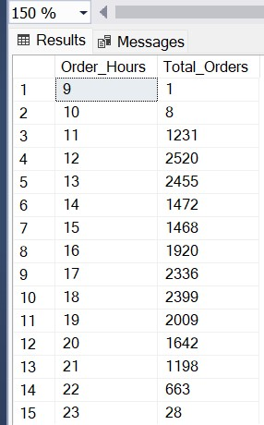

8.PERCENTAGE OF SALES BY PIZZA CATEGORY:

SELECT pizza_category, SUM(total_price) *100 / (SELECT SUM(total_price)

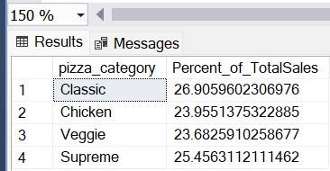 FROM pizza) AS Percent_of_TotalSales FROM pizza GROUP BY pizza_category

9.PERCENTAGE OF SALES BY PIZZA SIZE:

SELECT pizza_size, SUM(total_price) *100 / (SELECT SUM(total_price)

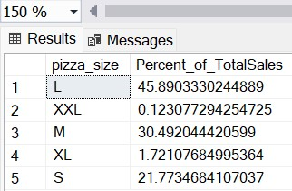 FROM Pizza) AS Percent_of_TotalSales FROM Pizza GROUP BY pizza_size;

10.TOTAL PIZZA SOLD BY PIZZA CATEGORY:

SELECT pizza_category, SUM(quantity) AS Total_Pizza_Sold FROM

pizza GROUP BY pizza_category;

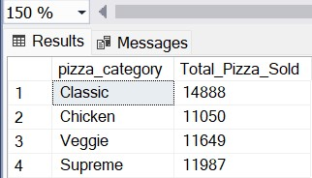

11.TOP 5 BEST SELLERS BY TOTAL PIZZA SOLD:

SELECT TOP 5 pizza_name, SUM(quantity) AS Total_Pizza_Sold FROM pizza GROUP BY

pizza_name ORDER BY SUM(quantity) DESC;

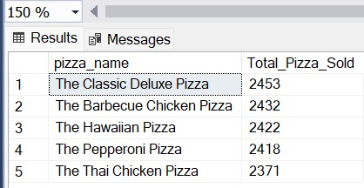

12.BOTTOM 5 WORST SELLERS BY TOTAL PIZZA SOLD:

SELECT TOP 5 pizza_name, SUM(quantity) AS Total_Pizza_Sold FROM pizza GROUP BY

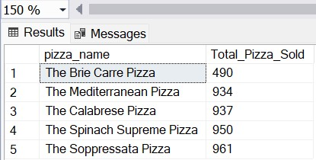 pizza_name ORDER BY SUM(quantity) ASC;